Diabetes Treatment 2008, A Review
Diabetes has become a common chronic disease, with type 2 diabetes (T2DM), accounting for the vast majority of cases. In Ontario, there was a 31% increase in yearly incidence with the 1995 and 2003 with a prevalence of about 8.8% in 2005.The DIASCAN study, published in 2001, found that 16.4% of primary care visits for patients 40 or older had known diabetes. This data was further supported by an Ontario study which found that the diabetes incidence rates were greater in those under 50 (94% increase in 20-49 year olds vs 63% increase in those over 50 and older, p<0.0001).  The incidence of type 2 diabetes is increasing at a dramatic rate with projection by the World Health Organization (WHO) that there will be 300 million people with diabetes worldwide by 2025, which is a doubling from the rate in the year 2000. Much of this is attributable to increased obesity secondary to increased consumption of energy dense foods and a more sedentary life style.  There are a number of factors that will contribute to an increasing prevalence of diabetes in Canada including:  - an aging population,  - an increased immigration from populations at high risk for diabetes  - an increasing worldwide prevalence of obesity  - an increase in the aboriginal population - who are especially predisposed to developing diabetes  - an increasingly sedentary population |  | 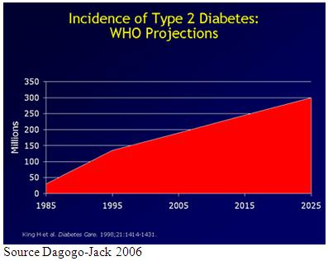
The natural history and pathophysiology of diabetes is becoming better understood. The following factors or steps appear to be involved.  Diabetes begins with a genetic predisposition to energy efficiency, and exposure to an excess of calories, both through increased intake (energy dense foods) and reduced output (a sedentary lifestyle). With the expansion of visceral fat stores comes increased production of hormones (e.g. resistin, fasting-induced adipose factor (FIAF)) and intermediate metabolites (free fatty acids) which interfere with insulin signalling.  With progressively worsening insulin resistance comes a demand for greater and greater secretion of insulin. Hyperinsulinemia, associated with insulin resistance can be considered a preliminary phase in the progression of future diabetes.  These prediabetic stages of impaired fasting glucose (IFG) and impaired glucose tolerance (IGT), occur for variable periods of time in people, depending on their genetic makeup and other factors. Some individuals may progress rapidly to overt type 2 diabetes, whilst others may progress fairly gradual. A small proportion may even recover from this intermediate stage. This recovery is called reversion to normal glucose tolerance. |  | 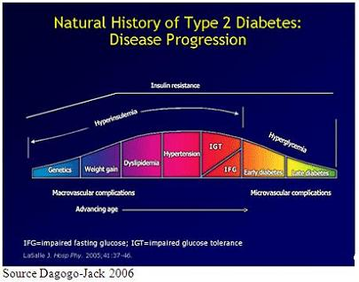

DEFINITIONS  Plasma glucose levels for diagnosing IFG, IGT, and diabetes (CDA Guidelines 2003)  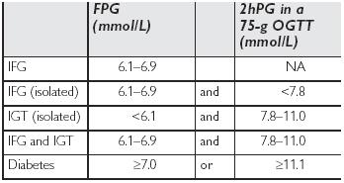  2hPG = 2-hour plasma glucose  FPG = fasting plasma glucose  IFG = impaired fasting glucose  IGT = impaired glucose tolerance  NA = not applicable  OGTT = oral glucose tolerance test  PG = plasma glucose |  | DIAGNOSIS OF DIABETES  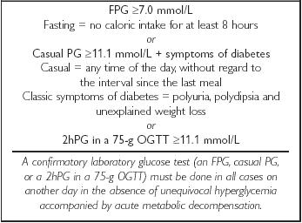

Reduced physical activity and being overweight are the major precursors of, and the most modifiable risk factors for, diabetes.
Primary risk factors for T2D:
- First-degree relative with diabetes
- Member of high-risk population (e.g. people of Aboriginal, Hispanic, Asian, South Asian or African descent)
- History of IGT or IFG
- Presence of complications associated with diabetes
- Vascular disease
- History of gestational diabetes mellitus
- History of delivery of a macrosomic infant
- Hypertension
- Dyslipidemia
- Overweight
- Abdominal obesity
- Polycystic ovary syndrome
- Acanthosis nigricans
- Schizophrenia
- Other risk factors
Goals of Interventions
The primary goal for intervention in patients with T2DM is to normalize both the fasting blood glucose as well as the postprandial blood glucose. There is good evidence that meeting and maintaining near-normal glycemia reduces the risks of long-term complications that occur with diabetes and improves the quality of life of the patient. Nevertheless it is apparent that despite lifestyle and pharmacologic interventions glucose levels increase over time in T2DM. It is believed that this is due to declining beta cell function.
Ideally, interventions in diabetes need to decrease insulin resistance and increase insulin to normal levels. Early interventions may make glucose normalization easier as the changes required will be smaller and many of the complications of diabetes will not yet have occurred. The clinical rationale for earlier intervention is predicated on the fact that macrovascular complications often appear even before the onset of diabetes.

Insulin resistance is a separate state that needs to be addressed independently of T2D
Currently, management of type 2 diabetes is by a stepwise approach that targets the pathophysiologic contributors to T2DM.
Type 2 diabetes is also associated with:
- Hypertension
- Dyslipidemia
- Decreased fibrinolytic activity (hypercoagulability)
- Enhanced activity of inflammatory markers/mediators
The first step in the management of T2DM is the reduction of blood glucose concentrations through diet and lifestyle interventions with weight loss as a primary goal. When dietary intervention fails agents such as, metformin, thiazolidinediones (TZDs), sulfonylureas, or insulin can be used to normalize glucose levels. Although the traditional oral agents (metformin and SUs) are initially efficacious, progressive loss of glycemic control occurs and has been shown to correlate with declining beta-cell function. Diabetes is a complex multi-step disorder: Genetics/environmental stress → insulin resistance → beta cell dysfunction → diabetes
Data suggests that in subjects with IGT, Acarbose and Metformin reduce incident diabetes by 25-30% while programmes of lifestyle interventions that target diet and physical activity reduce incident diabetes by more than 50%, but may be difficult to make universally available.
The thiazolidinediones (TZDs) reduce insulin resistance and improve insulin sensitivity. The TZDs can improve peripheral insulin sensitivity and reduce hepatic glucose production.
While early diagnosis and diet and lifestyle intervention are important and can reduce or delay diabetes in some people, it has limited effects in others. Several antihyperglycemic agents: metformin, acarbose and rosiglitazone have been proven to decrease the progression from IGT to diabetes mellitus, thereby delaying the onset of diabetes. Glycemic control is also very important in the prevention of complications of diabetes. Clinical data has provided compelling evidence that long-term complications of diabetes mellitus can be reduced by tight glycemic control. Evidence also suggests that despite the availability of several new classes of oral antidiabetic agents and insulin analogues, many patients with T2DM do not achieve optimal glycemic control.
The Canadian Diabetes Association (CDA) Clinical Practice Guidelines (2003) emphasize that the management regimens of patients, at risk of developing T2DM or who have T2DM, need be tailored to the individual's needs and circumstances, with the choice of antihyperglycemic agent(s) based on factors outlined in the table below. Treatment with oral antidiabetic agents not only improves glycemic control, but can also prevent diabetic complications.
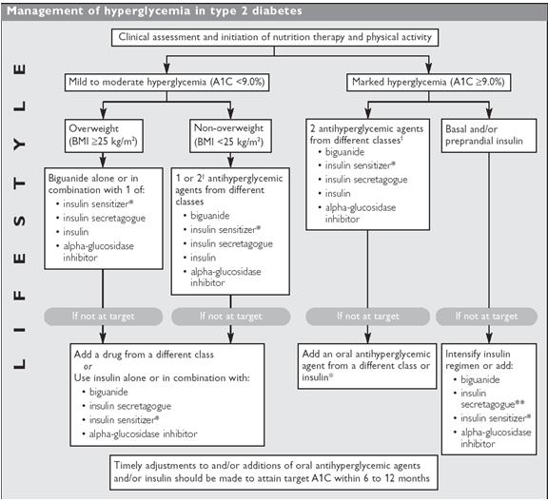
It is also well understood that insulin resistance frequently precedes the development of type 2 diabetes, although not all individuals who are insulin resistant develop clinical diabetes. Subjects with impaired glucose tolerance and insulin resistance appear to progress to type 2 diabetes at variable rates, depending on factors such as obesity, ethnicity, lack of physical activity, continued weight gain, and, especially, declining β-cell function. Studies have shown that improving insulin sensitivity with agents such as the thiazolidinediones (TZDs) can reduce insulin resistance associated with type 2 diabetes as well as significantly improve a number of important markers of cardiovascular risk.
Blood-glucose lowering medications can be divided into 5 groups by their mode of action:
- Those that reduce peripheral tissue insulin resistance - primarily the thiazolidinediones, but biguanides act similarly to an extent.
- Those that reduce glucose production by the liver - Biguanides are the main group, although the thiazolidinediones (TZD) have some action on the liver.
- insulin secretagogues - stimulate the pancreas to release more insulin. This group includes sulphonylureas such as glyburide which release more insulin, unrelated to time or glucose level
- Those (alpha-glucosidase inhibitors) that slow the absorption of complex sugars and therefore slow the rise in glucose.
- GLP-1 (incretins) - increase the response of the beta cells to circulating levels of glucose, currently not available in Canada.
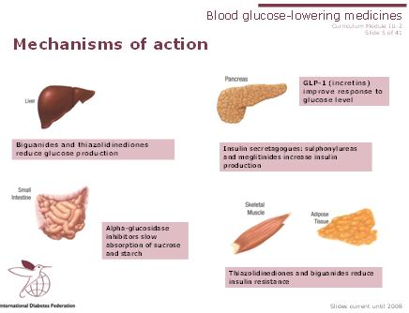
Source IDF Diabetes education modules accessed May 2007
Biguanides  - Mode of action not fully understood  - Decreases glucose production in liver  - Mild and variable effect on muscle sensitivity to insulin  - e.g. metformin  Side effects  - Gastrointestinal (nausea, abdominal discomfort or diarrhea and occasional constipation) occur in about 30% of patients using metformin. However, by starting with low doses (even as low as ¼ tablet) and gradually increasing the dose, tolerance appears to develop to the side effects and most can go on to the maximum dose. A relatively small number of people do not tolerate this family of medication. Titrating the dose is very important to develop tolerance and to assist patient's with staying on this medication.  - Lactic acidosis is extremely uncommon and tends to develop when given despite contraindications.  Contraindications  - Renal insufficiency (creatinine clearance <60 ml/min)  - Liver failure  - Heart failure  - Severe gastrointestinal disease  Advantages  - Rarely will cause hypoglycaemia when used as mono-therapy  - Does not cause weight gain; may contribute to weight loss |  | Thiazolidinediones (TZDs)  - Improve sensitivity to insulin in muscle, adipose tissue and liver  - Reduce glucose output from liver  - Changes fat distribution by decreasing visceral fat and increasing peripheral fat  - Reduce levels of LDL-cholesterol and increase levels of HDL-cholesterol  - Slow rate of beta-cell loss  - e.g. pioglitazone and rosiglitazone  Side effects  - Weight gain, fluid retention  - Upper respiratory infection and headache  - Decrease in haemoglobin due to fluid retention  - Slight increased risk of heart failure  - Slight increased risk of upper limb and foot fractures in women  Contraindications  - Liver disease, heart failure or history of heart disease  - Pregnancy and breast feeding  They are not contraindicated in renal insufficiency
Insulin Secretagogues  Sulphonylureas  - Increase insulin secretion regardless of blood glucose levels  - Many different medicines in this class eg. chlorpropamide, tolbutamide, glyburide, glibenclamide, glipazide, glimeperide and gliclazide  Side effects  - Hypoglycaemia- especially when activity levels increase or meals are late or missed  - Weight gain common as drugs stimulate appetite and due to need to eat to address low blood glucose levels.  - Nausea, fullness, heartburn  - Occasional rash  - Swelling  Contraindications  - Type 1 diabetes  - Pregnancy  - Breastfeeding  → Use cautiously with liver or kidney disease |  | Non sulfonylureas  - reduce postprandial glycemia  - nateglinide & repaglinide  Side effects  - GI disturbances including abdominal pain and dyspepsia  - Less hypoglycemia in the context of missed meals  - Hypoglycemia with repaglinide  Contraindications  - Type 1 diabetes  - Diabetic ketoacidosis  - Gemfibrozil with repaglinide

Alpha glucosidase inhibitors  - Slow digestion of sucrose and starch and therefore delay absorption  - Slow post-meal rise in blood glucose  - e.g. acarabose  Side effects  - Flatulence, abdominal discomfort , diarrhea  - As mono-therapy will not cause hypoglycaemia  - Hypoglycaemia when used with other medicine (e.g. a sulphonylurea). Hypoglycemia needs to be treated with dextrose, if not available, drink milk or use honey; not conventional juice or pop.  → side effects can be very pronounced, best to start with small doses and gradually increase the dose as tolerated  Contraindications  - Intestinal diseases, such as Crohn's. This class of medicine is not absorbed systemically therefore contraindicated in people with previously existing intestinal disease.  - Autonomic neuropathy affecting the gastro-intestinal tract  → Must be taken just before a meal, will not be effective if taken after a meal. |  | Incretin mimetic agent (currently not available in Canada)  - Improves beta-cell responsiveness to increasing glucose levels  - Decreases glucagon secretion  - Slows gastric emptying  - Results in a feeling of fullness or satiety  - Must be injected subcutaneously twice a day, within 30-60 minutes before a meal  - Reduces HbA1c by ~1%  - e.g. GLP-1 agonist/analog (glucagon like peptide)  Side effects  - Nausea  - Weight loss  - Diarrhea  - Risk of hypoglycaemia when used with a sulphonylurea  → starting with a low dose and slowly increasing the dose will help minimize side effects in most people  Contraindications  - End-stage kidney disease or renal impairment (creatinine clearance <30mL/min)  - Pregnancy  - Severe gastrointestinal disease
DPP-4 Inhibitors
- Prolongs levels of endogenous GLP-1 by 2-3 fold
- Improves islet cell function by increasing insulin in glucose dependent fashion i.e. no hypoglycemia
- Also decreases glucagon secretion
- Once-daily oral agent
- Weight neutral
- e.g. sitagliptin
Side Effects
- In general, tolerability similar to placebo apart from mild increase in nausea
- Very rare cases of serious hypersensitivity reactions e.g. Stevens-johnson syndrome
Concerns:
- not recommended in patients with moderate or severe renal insufficienncy or severe hepatic insufficiency
- not recommended in pregnant and nursing women or in pediatric populations
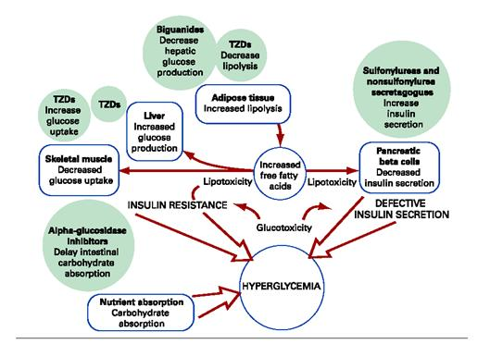
Source Triplitt 2007
Evidence is emerging that (TZDs) can reduce the risk of diabetes in patients with prediabetes (IGT/IFG).. The TZDs are PPARγ agonists, a class of drugs that reduce fasting and postprandial glucose levels by increasing insulin sensitivity. TZDs appear to primarily augment insulin-stimulated glucose uptake in muscle and adipose tissue, ultimately, decreasing insulin resistance in these tissues and, to a lesser extent, in hepatic tissue. When used as monotherapy, TZDs are able to decrease plasma glucose and glycosylated hemoglobin (HbA1c) levels with minimal hypoglycemia. Studies have shown that glycemic response and insulin sensitivity index, after glucose administration and meals, were also improved in TZD-treated patients.
Evidence supports that while TZDs effectively lower blood glucose, they also appear to benefit some cardiovascular parameters, such as HDL, TC/HDL profiles, blood pressure, inflammatory biomarkers, endothelial function, and fibrinolytic status. With the most common side effect of TZDs being edema, clinicians need to determine if the observed edema is an indication of congestive heart failure (CHF). Clinicians should be cognizant that CHF or left ventricular dysfunction (systolic or diastolic) may occur over time during TZD treatment. It is important to note that CHF has not been frequently reported in clinical trials using TZDs. In fact, the recent ADOPT trial reported that in the study population fewer than 1.5% of 1456 patients developed CHF over the 4 year trial whether on rosiglitazone or metformin, while those treated with glyburide had an incidence of 0.6%
Recognizing that the management of edema or CHF could be challenging, the American Diabetes Association and the American Heart Association released recommendations for managing patients with CHF being treated with TZDs. According to these guidelines
→ Once on TZDs, patients should be instructed to monitor for weight gain or the presence of pedal edema. If edema develops, particularly within the first few months of TZD therapy, the physician should determine whether CHF is present
→ If edema occurs and CHF is not present during TZD therapy, other causes of the edema should be investigated before attributing it to the TZD
→ If a new diagnosis of CHF is made or considered likely, even in the absence of prior left ventricular dysfunction, the use of the TZD should be reconsidered. Dosage change and temporary or permanent discontinuance are the obvious options, but the choice of such interventions should be individualized. Treatment directed to CHF should be initiated. In the absence of systolic dysfunction, only diuretics such as furosemide may be necessary. However, more recent data suggests that spironolactones are preferred over furosemide and hydrochlorothiazides in the treatment of edema associated with TZD use. The duration of diuretic therapy can be quite variable, as the need for diuresis may be temporary if the patient improves and fluid retention disappears with the discontinuation of the TZD.
→ For patients with known left ventricular dysfunction who develop CHF while on a TZD, the drug should be discontinued, and therapy with diuretics, angiotensin-converting enzyme inhibitors, angiotensin receptor blockers, β-blockers, and digoxin should be considered and titrated according to the severity of the patient's condition and current treatment guidelines for CHF.

In current practice, TZDs are often added as second-or third-line agents to patients not at goal on monotherapy with a biguanide or a sulfonylurea. Addition of TZDs may not take place until after a prolonged period of inadequate control on prior therapy. Emerging evidence indicates that many patients would likely benefit from more timely and aggressive implementation of antidiabetic therapy with TZDs. The recently completed ADOPT trial demonstrated that when TZDs are used early in the course of disease glycemic control is more sustained, compared to metformin or glyburide. An insulin sensitizer may therefore be an appropriate treatment strategy for earlier diabetes management given their beneficial effects of insulin sensitization on beta cell function as well as peripheral and hepatic insulin resistance. While metformin may also improve peripheral insulin sensitivity, it does so to a lesser extent when compared with TZDs, and its main action is to reduce hepatic glucose production.
Current CDA recommendations, for overweight patients with mild to moderate hyperglycemia (A1C <9.0%), are for initial treatment with metformin, alone or in combination with an insulin sensitizer (i.e. TZD), in patients who have not been adequately controlled after 2 to 3 months of lifestyle modification. The guidelines also suggest that 2 antihyperglycemic agents, or insulin, be initiated concomitant with lifestyle counselling in those with severe hyperglycemia (A1C ≥ 9.0%).
In contrast to traditional agents used in the United Kingdom Prospective Diabetes Study (UKPDS), the recent ADOPT trial indicates that rosiglitazone reduces the rate of loss of glycemic control , indicating that early use of rosiglitazone provides more durable antihyperglycemic effect compared to glyburide and metformin. This effect may also help to limit the occurrence or the progression of diabetic complications.
Diabetes REduction Assessment with ramipril and rosiglitazone Medication (DREAM trial)  The DREAM trial was designed to assess prospectively if rosiglitazone or ramipril could reduce the frequency of diabetes in individuals with IGT, IFG, or both, in a 2-by-2 factorial design,  The study included 5269 adults aged 30 years or more with IFG, IGT, or both, who had no previous CVD. Adults were recruited from 191 sites in 21 countries and were randomly assigned to groups and were followed for a median of 3 years. |  | 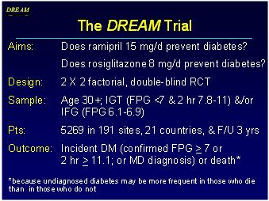
Ramipril Arm  Participants received ramipril (up to 15 mg per day; n=2623) or placebo (n=2646)  In the ramipril arm of the trial, the incidence of diabetes did not differ significantly between the ramipril group (18.1%) and the placebo group (19.5%). The study found that participants receiving ramipril were more likely to have regression to normoglycemia than those receiving placebo (hazard ratio, 1.16; 95% CI, 1.07 to 1.27; P = 0.001).  Ramipril Conclusions  Among persons with impaired fasting glucose levels or impaired glucose tolerance, the use of 15 mg of ramipril for 3 years does not significantly reduce the incidence of diabetes or death but does significantly increase regression to normoglycemia. (ClinicalTrials.gov number, NCT00095654.)  Ramipril Summary and Conclusions  - Modestly improves glycemic status in IFG/IGT  - A nonsignificant 9% diabetes reduction  - Significant 16% increase in regression to normal glucose levels by at least 2 yrs  - Reduced 2 hr glucose by 0.3 mM by study end  - Significantly reduces BP in IGT / IFG  - Small, favorable effect on liver function  - DREAM results provide the best estimate of the effect of ACE-Inhibitors on diabetes prevention in people with IFG / IGT and no previous CVD  - Ramipril cannot currently be recommended for diabetes prevention  - However, in people in whom there is an indication for ACE inhibitors (high BP, CHF, vascular disease, high risk DM) the favorable effects on glucose may be of added benefit |  | 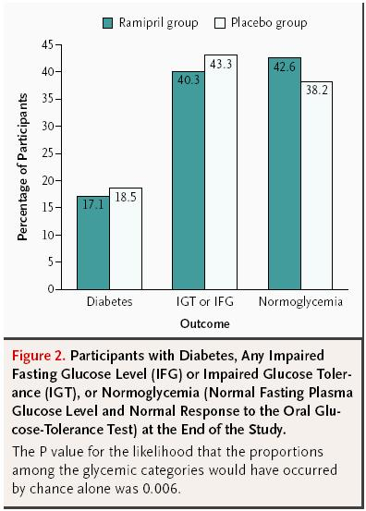
In the rosiglitazone arm of the study, 50.5% (1330) individuals in the rosiglitazone group and 30.3% (798) in the placebo group became normoglycaemic (1•71, 1•57 -1•87; p<0•0001). The cardiovascular event rates were similar in both groups, although 14 (0.5%) participants in the rosiglitazone group and two (0.1%) in the placebo group developed congestive heart failure (p=0.01).  The study found that absolute risk difference between treatment groups of 14.4% indicates that for every seven people, with IFG or IGT, prescribed rosiglitazone for 3 years, one will be prevented from developing diabetes. Rosiglitazone also appears to significantly increase the likelihood of regression to normoglycaemia, by about 70-80% compared with placebo. The data reported in this study is of similar magnitude as the reduction in diabetes achieved with lifestyle approaches alone and is greater than the diabetes reduction reported previously with metformin or acarbose.  Rosiglitazone Conclusions  Rosiglitazone at 8 mg daily for 3 years substantially reduces incident type 2 diabetes and increases the likelihood of regression to normoglycemia in adults with impaired fasting glucose or impaired glucose tolerance, or both.  Rosiglitazone Summary and Conclusions  - A dose of 8 mg/day reduces new diabetes by > 60% in people with IGT or IFG  - Promotes regression to normal FPG and 2 hr PG by >70%  - Effective in all regions of the world  - Eliminates the gradient of diabetes risk with increasing weight  - ~ 3% increase in body weight, but a favorable effect on waist/hip ratio  - Reduces ALT  - Modestly lowers systolic BP & diastolic BP  - Increases the risk of CHF  - Too few events to draw any conclusions re the effect on other CV events or death  - For every 1000 people treated with rosiglitazone for ~ 3 years, 144 cases of DM will be prevented with an excess of ~ 4 cases of CHF  The DREAM trial concluded that rosiglitazone at 8 mg daily for 3 years substantially reduces incident type 2 diabetes and increases the likelihood of regression to normoglycaemia in adults with impaired fasting glucose or impaired glucose tolerance, or both.  Conclusions of the DREAM Trial  → Rosiglitazone has a substantial benefit on prevention of diabetes and regression to normoglycaemia  → Ramipril has a modest benefit on regression to normoglycaemia  → The durability of the glycaemic effect of these drugs is being assessed in a washout phase |  | Rosiglitazone Arm Patients received rosiglitazone (8 mg daily; n=2365) or placebo (2634).  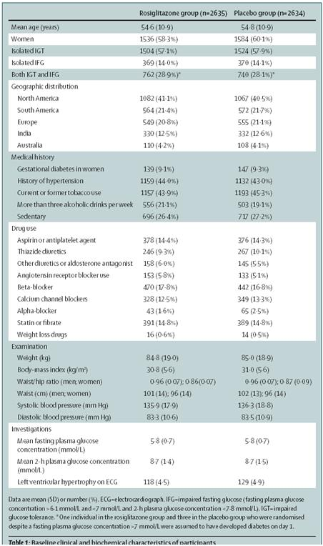

The ADOPT trial was designed to determine if rosiglitazone, metformin, or glyburide (representing the three most widely used classes of oral antidiabetic agents) might alter disease progression through direct or indirect actions. Individuals with recently developed diabetes (less than 3 years, with an average of 8 months of diabetes history) were enrolled and treated. Patients were followed to an end point that consisted of a strictly and rigorously defined failure of monotherapy. The purpose of the trial was to determine which one of the 3 drugs was able to provide patients with the most durable glycemic control when given as initial monotherapy.  ADOPT RESEARCH DESIGN AND METHODS  A Diabetes Outcome Progression Trial (ADOPT) was a randomized, double-blind, parallel-group study consisting of a screening visit, a 4-week placebo run-in, a 4-year treatment period, and an observational follow-up of ~3,600 drug-naive patients with type 2 diabetes diagnosed within the previous 3 years. After run-in, patients were randomized to rosiglitazone, glyburide, or metformin titrated to the maximum effective daily doses (8 mg rosiglitazone, 15 mg glyburide, or 2 g metformin).  Primary outcome was time to monotherapy failure, defined as the time following titration to the maximal effective or tolerated dose when fasting plasma glucose exceeds 10 mmol/l.  Secondary outcomes included measures of islet β-cell function, insulin sensitivity, dyslipidemia, changes in urinary albumin excretion, plasminogen activator inhibitor-1 antigen, fibrinogen, and C-reactive protein.  Safety and tolerability were also evaluated as were patient-reported outcomes and resource utilization data.  8 mg rosiglitazone, or 15 mg glyburide, or 2 g metformin  ADOPT ENROLLMENT  On average the patients were middle-aged, predominantly white, and obese (body-mass index BMI >30), with no significant differences in baseline variables among the groups.  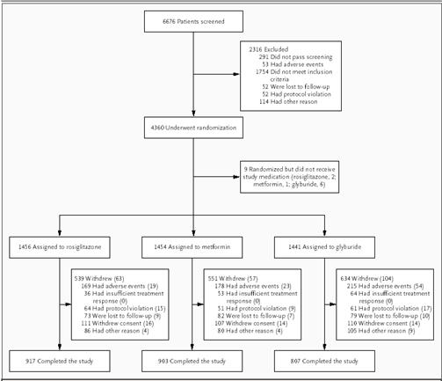  In a double-blind regimen, patients received initial daily doses of 4 mg of rosiglitazone, 500 mg of metformin, or 2.5 mg of glyburide, all prepared in identical looking capsules. For each drug, the dose was increased according to the protocol to the maximum daily effective dose (4 mg of rosiglitazone twice daily, 1 g of metformin twice daily, and 7.5 mg of glyburide twice daily). A dose increase was required at each visit if the fasting plasma glucose level was ≥7.8 mmol/L; a dose reduction was permitted if adverse events occurred.  ADOPT RESULTS  The proportion of patients who either reached the primary outcome or completed the study was 63% in the rosiglitazone group, 62% in the metformin group, and 56% in the glyburide group. The primary reason for non-completion of the study was adverse events (12% of patients in the rosiglitazone group, 12% in the metformin group, and 15% in the glyburide group).  Although, monotherapy failed in some patients, the cumulative incidence monotherapy failure was significantly less in the rosiglitazone group. Treatment was considered to have failed if a patient had a confirmed or adjudicated level of fasting plasma glucose > 10 mmol/L.  Monotherapy failure:  - 143 patients in the rosiglitazone group, (2.9 per 100 patient-years)  - 207 patients in the metformin group (4.3 per 100 patient-years)  - 311 patients in the glyburide group (7.5 per 100 patient-years).  Kaplan-Meier cumulative incidence at 5 years:  - 15% with rosiglitazone  - 21% with metformin  - 34% with glyburide  Risk (incidence) Reduction*:  - 32% with rosiglitazone as compared with metformin (95% confidence interval [CI], 15 to 45)  - 63% with rosiglitazone as compared with glyburide (95% CI, 55 to 70) *(P<0.001 for both comparisons).  Subgroup analyses of the study suggests that the treatment effect was greater with rosiglitazone than with metformin among older patients (≥50 years of age) and among those with a larger waist circumference (>110 cm). Rosiglitazone was found to be more effective than glyburide in all subgroups.  DAILY DOSING: |  |  | 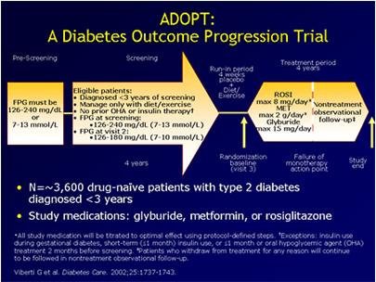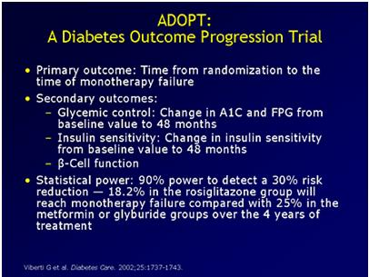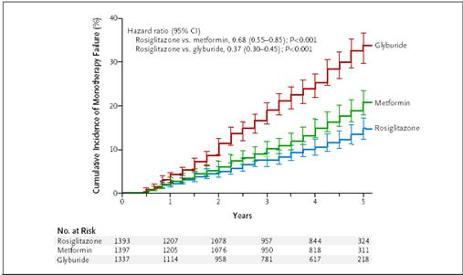
ADOPT CONCLUSIONS
The authors of the ADOPT trial concluded that initial treatment of type 2 diabetes with rosiglitazone during a median period of 4 years slowed progression to monotherapy failure (defined as a fasting plasma glucose level >10 mmol/L) more effectively than did either metformin or glyburide. They also observed a lower threshold for monotherapy failure (FPG >7.8 mmol/L) with rosiglitazone compared with current therapeutic approaches to glucose management. Rosiglitazone was more effective overall than metformin, although heterogeneity analyses demonstrated no sub-group differences apart from a greater effect in older patients and those with a larger waist circumference.
In a head to head comparison of the three drugs the authors concluded that progressive loss of glycemic control can be delayed and a mean level of glycated hemoglobin maintained at less than 7% for a longer period with rosiglitazone (57 months) than with either metformin (45 months) or glyburide (33 months). The authors conclude that their findings also confirm the value of metformin as an initial treatment for type 2 diabetes, with greater efficacy than glyburide.
The study also found that rosiglitazone slowed the rate of loss of beta-cell function and improved insulin sensitivity to a greater extent than either metformin or glyburide. This is evidenced by the greater durability of glycemic control achieved with rosiglitazone.
Most common adverse events*:
- Rosiglitazone
  - Weight gain, edema
  - To manage or treat edema in patients on a TZD, clinical data suggests that spironolactone is more effective than furosemide or thazide in managing rosiglitazone induced fluid retention.
  - To minimize weight gain on TZD, a weight management program can be instituted.
- Metformin
  - GI side effects
  - To manage or limit the GI side effects in patients on metformin it is recommended to initiate therapy at a low dose and slowly titrate the dose up to therapeutic response. Another recommendation is to use a combination of oral antihyperglycemic agents at sub-maximal doses to limit GI effects.
- Glyburide
  - Weight gain, hypoglycemia
  - To correct the hypoglycemia in patients on a sulfonlyurea it is recommended that shorter-acting insulin-stimulating drugs such as gliclazide, repaglinide, or glimepiride be considered as an alternate choice.
*there were no unexpected adverse events in any of the treatment groups
OVERALL:
The potential risks and benefits, the profile of adverse events, and the costs of these oral agents should all be considered to help inform the choice of pharmacotherapy for patients with type 2 diabetes.
Key Learning Points
- Early intervention in type 2 diabetes can alter disease progression.
- Aggressive use of antidiabetic therapy, including rosiglitazone, early in the course of diagnosed T2D appears to have a significant effect on disease progression
- In diabetes management the risks and benefits of each therapy need to be considered on a patient to patient basis.
References
Manuel DG, Schultz SE. Diabetes health status and risk factors. In: Hux JE, Booth GL, Slaughter PM, et al, eds. Diabetes in Ontario. An ICES Practice Atlas. Toronto, ON: Institute for Clinical Evaluative Sciences; 2003:4.77-4.94. Available at: http://www.ices.on.ca.
Hux JE,Tang M. Patterns of prevalence and incidence of diabetes. In: Hux JE, Booth GL, Slaughter PM, et al, eds. Diabetes in Ontario. An ICES Practice Atlas. Toronto, ON: Institute for Clinical Evaluative Sciences; 2003:1.1-1.18. Available at: http://www.ices.on.ca. Accessed
Viberti G., et al. A Diabetes Outcome Progression Trial (ADOPT). Diabetes Care 25:1737-1743, 2002.
New Treatments, New Avenues in the Complicated Patient with Type 2 Diabetes and Hypertension, SE. Dagogo-Jack. 2006 http://www.medscape.com/viewprogram/5523_pnt

